**Maji Marwa**

**Water Treatment Plant: Hydraulics and Design**

**100% Design Document**

**Team Members: Andrew Bernard, Mike Reese,**

**Mike Travis, Maria Ulatowski**

**Submitted: April 22nd, 2019**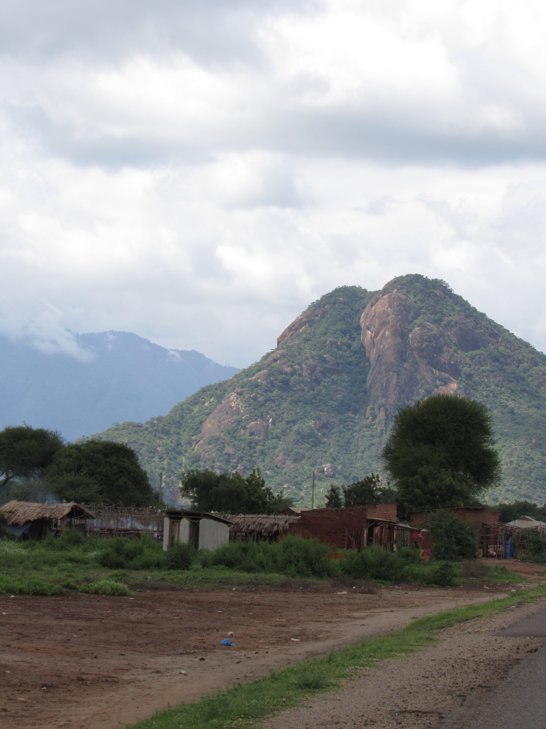

**Executive Summary**

Maji Marwa is a visionary project with the ultimate goal of providing a sustainable system of clean water to a group of sub-villages in Tanzania. The project, which was conceived in 2013 from a village chairman and university representatives, aims to construct an inlet from the Pangani River, a treatment facility in the village of Marwa, and a distribution system that will provide water to a population of 7,000 residents.

This report discusses the progress made to date on the second phase of the Maji Marwa Project: the design and construction of a water treatment plant. Also provided are detailed descriptions of unit processes in the proposed plant, as well as drawings showing what such a system will look like.

This design takes its inspiration from Cornell University’s “AguaClara” design and considers the implications of building such a system in Tanzania.

The design itself includes an entrance tank, coagulation and flocculation, sedimentation, filtration, and chemical disinfection. It is designed to be run at a flow rate of 36 liters per second with the intent to provide safe drinking water for the population of the 7000 people throughout the Marwa community and surrounding sub-villages.

**Acronyms and Abbreviations**

Alum, Aluminum Sulfate

CDC, Linear Chemical Dose Controller

CHT, Constant Head Tank

EPA, Environmental Protection Agency

IAD, AguaClara Information Accessibility Document

Kbaffle, Minor loss coefficient for a single baffle

KiHO, Kilimanjaro Hope Organization

LFOM, Linear Flow Orifice Meter

Maji Marwa, Water for Marwa

MPN, Most Probable Number

NTU, Nephelometric Turbidity Units

OSU, The Ohio State University

PACl, Polyaluminum Chloride

Sed Bay, Sedimentation Bay

SRSF, Stacked Rapid Sand Filter

UC, Uniformity Coefficient

UDOM, University of Dodoma

WHO, World Health Organization

**Acknowledgements**

First and foremost the team would like to thank Dr. Michael Hagenberger for his continued assistance, expertise, and encouragement. Without him, this project may not even exist and so the team is thankful for the opportunity to learn and grow on a project as meaningful and important as Maji Marwa. The team would also like to thank Patrick Sours and Randall Berkeley for their help throughout the capstone program. Their advice enabled the team to make better decisions and move forward with the project at hand. Additionally, many thanks to Kristin Conroy for her contributions to the treatment plant and for the knowledge she has passed on regarding chlorination and disinfection of contaminated water. The team would also like to thank Dr. Anthony Massari for his guidance and support for the project. Lastly, the team would like to personally thank everyone from AguaClara Cornell, Agua Para el Pueblo, and especially Dr. Monroe Weber-Shirk for their outstanding commitment to serving developing countries around the world. Their extreme generosity and expertise has enabled the design of the treatment plant to progress rapidly and confidently. It is inspiring and a privilege to be able to collaborate with a team as gifted and as motivated to improving quality of life for everyone as AguaClara.

**Contents**

**Executive Summary …………………………………………………………………………………………. 1**

**Acronyms and Abbreviations ……………………………………………………………………………... 2**

**Acknowledgements …………………………………………………………………………………………. 2**

1. **Project Background and Scope of Work ………………………………………………………. 5**
   1. Project Background ………………………………………………………………………... 5
   2. Scope of Work ……………………………………………………………………………… 5
   3. Existing Water Quality Conditions ………………………………………………………... 6
2. **System Components ………………………………………………………………………………. 6**
   1. Flow Control and Measurements …………………………………………………………. 7
   2. Rapid Mix ……………………………………………………………………………………. 13
   3. Flocculation …………………………………………………………………………………. 13
   4. Sedimentation ……………………………………………………………………………….18
   5. Filtration …………………………………………………………………………………….. 25
3. **Cost Estimate ……………………………………………………………………………………… 27**
4. **Remaining Work …………………………………………………………………………………... 28**
5. Available Resources ………………………………………………………………………. 28
6. Questions to Consider …………………………………………………………………….. 30
7. Next Steps ………………………………………………………………………………….. 31
8. Final Plans ………………………………………………………………………………….. 32
9. **Recommendations ………………………………………………………………………………... 33**

**Appendices**

Appendix A: Design Calculations and Data ………………………………………………………………... 34

Appendix B: Materials ….…………………………………………………………………………………….. 38

Appendix B: References …………………………………………………………………………………….. 42

Appendix D: Drawings ………………………………………………………………………………………. 43

**Tables**

Table 1 …………………………………………………………………………………………………………. 37

Table 2 …………………………………………………………………………………………………………. 38

Table 3 …………………………………………………………………………………………………………. 39

Table 4 …………………………………………………………………………………………………………. 40

Table 5 …………………………………………………………………………………………………………. 40

Table 6 …………………………………………………………………………………………………………. 41

**Figures**

Figure 1 ………………………………………………………………………………………………………….... 7

Figure 2 …………………………………………………………………………………………………………… 8

Figure 3 …………………………………………………………………………………………………………. ..10

Figure 4 …………………………………………………………………………………………………………. ..11

Figure 5 …………………………………………………………………………………………………………. ..12

Figure 6 …………………………………………………………………………………………………………. ..15

Figure 7 …………………………………………………………………………………………………………. ..16

Figure 8 …………………………………………………………………………………………………………. ..16

Figure 9 …………………………………………………………………………………………………………. . 18

Figure 10 …………………………………………………………………………………………………………. 19

Figure 11 …………………………………………………………………………………………………………. 20

Figure 12 …………………………………………………………………………………………………………. 21

Figure 13 …………………………………………………………………………………………………………. 21

Figure 14 …………………………………………………………………………………………………………. 22

Figure 15 …………………………………………………………………………………………………………. 23

Figure 16 …………………………………………………………………………………………………………. 23

Figure 17 …………………………………………………………………………………………………………. 24

Figure 18 …………………………………………………………………………………………………………. 25

Figure 19 …………………………………………………………………………………………………………. 27

**I. Project Background and Scope of Work**

1. **Project Background**

Maji Marwa is a vision for the development of a village located in rural Tanzania. Maji Marwa is located along the Pangani river. The new village will consist of four currently existing sub-villages: Lesierway, Marwa, Njakatai, and Pattel. These four sub-villages currently lack access to readily available, clean water. Instead, women and children within the villages are forced to labor to collect unsanitized water from the Pangani river. An extensive number of hours are spent collecting this water which limits opportunities for the people living in these sub-villages. For example, women lose the opportunity to contribute to the financial stability of their families, children lose the opportunity to maximize their education, and the entire community lacks the opportunity to have confidence in reliable and safe food sources. Meanwhile, the water which they do have access to is below the established standards for drinking water in Tanzania. Therefore, this project was intended to develop and design a water treatment and distribution system for the people of Maji Marwa so that they could reclaim the opportunities that have been stripped from them and have confidence in the safety of the water they are using.

The project has been delegated to several sub-project teams in order to best accomplish the tasks required. These sub-teams include: the inlet team, which is focused on designing a structure to withdraw and pump untreated water from the Pangani river to the water treatment plant; the water treatment team, which is focused on designing the water treatment facility which will clean the water drawn from the Pangani river; the distribution team, which is focused on designing the system for distribution and storage of the clean water from the treatment facility to the four sub-villages of Maji Marwa; the rainwater harvesting team, which is focused on providing a supplemental clean water system in addition to the water treatment facility; and the land development team, which is focused on planning for the future development and expansion of Maji Marwa and providing a model for other Tanzanian villages to follow in order to improve their quality of life. The general flow of the system is as follows: water will be drawn from the Pangani river by the inlet structure and subsequently pumped to the water treatment system which will include sediment removal in addition to chemical treatment of the water. After treatment, the water will then be fed to distribution tanks at each respective sub-village by gravity. The current distribution system is designed to serve a population of 7,000 people which accounts for population growth from the current residing population.

1. **Scope of Work**

A general plant design for 36 L/s has been finished, but must be specifically tailored for use in Marwa. 36 L/s was chosen as the design flow because it allows for a healthy supply of water to be provided for the projected population of 7000, while also allowing for the possibility of increased frequency of operation if more water is requested in the future. This base plant was created by researchers at Cornell University. Their student led organization is called AguaClara. Collaboration between Ohio State and Cornell has allowed for the exchange of ideas and improvements to several design components related to this plant. Special considerations are being made to construction, supply chain, and available resources in Tanzania in order to ensure the sustainability of the plant.

By April 22nd, the water treatment team will deliver a report detailing each process in the plant design, a hydraulic profile of the treatment system with design calculations, and general drawings of the plant design. A preliminary cost estimate based on these deliverables will also be provided so that a general idea can be given for funding purposes.

After phase one of the Maji Marwa project has been completed, the goal will be to build the 36 L/s plant based off of the information and specifications listed in this report.

1. **Existing Water Quality Conditions**

In early 2019, water quality data was obtained from Zaina Hussein, a professor at Ardhi University in Tanzania. Zaina’s data reflects water quality for the dry season in Tanzania. This data is available in Appendix A. Zaina collected data at two different intake locations known as Timothy Intake and Nyakatai Intake. The data offers a glimpse of how the measured parameters compare to the Tanzanian standards. The only parameter that falls substantially out of range is the number of coliforms per 100 mL. Nevertheless, other values fall outside of what is required through WHO or the United States’ own standards. For example, WHO allows for turbidity values only under 5 NTU, while the current reading from the Pangani is 22 NTU. Furthermore, the presence of coliforms alone in the water means that it requires some type of treatment. The required value for coliforms is 0 MPN/100 mL in almost any case around the world, because the existence of coliforms is representative of the existence of pathogenic organisms and viruses.

In May of 2019, Ohio State and UDOM students on the water quality testing team will be conducting tests on these same two intakes in hopes of gathering data during the wet season. Different weather patterns and events like rain can result in changes in water quality due to runoff or flooding. The team aims to test as many of the parameters tested by Zaina as possible to determine whether plant operation will need to change with the season.

**II. System Components**

The following section will detail the major system components that comprise AguaClara water treatment plant technology. Each component will be described based upon the function it serves within the plant as well as what the technology looks like specific to the AguaClara design. System components discussed throughout this section include: (1) Flow control and measurement of chemical dosing throughout the plant (Entrance tank); (2) Rapid mix design for coagulation; (3) Flocculation process and design; (4) Sedimentation process and design; and (5) Filtration process and design. All assumptions made for individual system components are directly influenced by the AguaClara textbook for water treatment plant design.

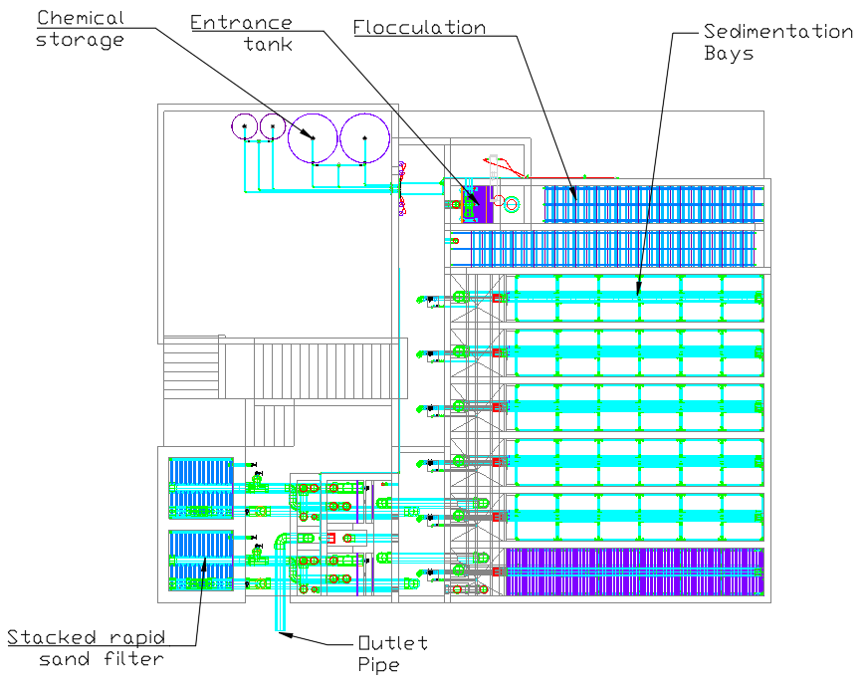

***Figure 1:*** *36 L/s plant layout.*

1. **Flow Control and Measurement**

The design of flow control and measurement within the AguaClara plant is focused upon maintaining a constant head of coagulant for the chemical dosing of influent water. This means that the energy level or head throughout the chemical dosing system will not change. Consequently, constant flow should be maintained through the system as there is no change in energy to disturb the flow of the water. Preserving constant head throughout chemical dosing can prove challenging in that the total concentration of chemicals in the untreated water must remain the same. Thus, if the flow rate through the plant changes then the continuous flow of chemicals must change proportionately. It is important to maintain a specific dose through the plant as the concentration of chemicals in the raw water directly relates to the success of critical water purifying processes such as coagulation and chlorination. Proper coagulant dosing allows for the formation of larger particles within the water making it easier to capture and remove these unwanted sediments, but it is highly dependent upon water characteristics such as turbidity (quantity of sediment and other particles such as clay and bacteria in the water) and the amount of organic matter present. Accurate and steady chlorine dosage is critical to effective water treatment as too little chlorination affords the opportunity for pathogens and bacteria to re-enter the water while too much chlorination increases the chances of carcinogenic disinfection byproducts (i.e. trihalomethanes, bromate, etc.) forming in the water. (Weber-Shirk: FC&M Design)

There are two components within the AguaClara system that are designed to control flow through the plant. These components are: (1) the Linear Flow Orifice Meter (LFOM) and (2) the Linear Chemical Dose Controller (CDC). This section will discuss each of these components describing what the component is, what it does in the AguaClara plant and why, and lastly how the component works. A third component the “Almost Linear” Flow Controller was replaced by the CDC, but will still be discussed for total comprehension of the AguaClara design and its evolution.

The “Almost Linear” Flow Controller consists of a Constant Head Tank (CHT) which holds the appropriate chemical solution, a float valve to maintain constant water level within the CHT, and a flexible tube starting at the base of the CHT which connects to a pipe with many precisely placed and equally spaced holes. The appropriate chemical solution is stored at a height above the CHT and a separate tube connects the stock tank to the float valve within CHT. The “Almost Linear” Flow controller was designed to provide a constant flow of chemical solution into the water entering the system. Each hole within the pipe has a fixed elevation difference between the water level in the CHT and the pipe itself. By placing the end of the flexible tube in one hole or another, the operator can control the constant flow at which the chemical solution is introduced to the influent water. Knowing that the dose must be held constant within the untreated water but that the flow of water into the plant as well as the influent water characteristics (i.e. turbidity) are variable requires that the amount of chemical solution added to the raw water be variable also. The “Almost Linear” Flow Controller accomplishes this variability by enabling the operator to quickly and easily change which hole the flexible tube from the CHT connects to in the flow control pipe. Not only is this a quick and easy way to adjust the dosage of chemical solutions to the raw water, but it also allows the operator to know the value of the new dose they set. The “Almost Linear” Flow Controller works by maintaining a linear relationship between flow of chemicals out of the CHT (*Q*) and the elevation difference between the water level in the CHT and the end of the flexible tube (*hL*), which is determined by what hole the flexible tube is placed in. However, in order for a linear relationship to be upheld between these two variables, laminar flow must always be present in the flexible tube that connects the CHT and the flow control pipe and major losses must always far exceed the minor losses through the flexible tube (AGUA TEXT: Paragraph 102). Due to the flexibility of the tube and the unpredictability of bends between the CHT and the flow control pipe, the “Almost Linear” Flow controller was unable to achieve a system where major losses far exceeded minor losses. Since the relationship between flow and driving head was only “almost linear” the component was redesigned and replaced by another component which could achieve linearity between these two variables.

The Linear Flow Orifice Meter (or LFOM for short) was the replacement component to the “Almost Linear” Flow Controller. Essentially, the design consists of a series of holes drilled into a pipe in rows which is intended to resemble a particular weir type known as a Sutro weir. The number of holes (or orifices) per row increases as you move down the LFOM pipe such that two half parabolas form on each side. Each orifice is the same size and the number of orifices per row is precisely calculated. Water flows from the entrance tank into the LFOM and on to the rapid mix orifice and flocculator. Figure 2 below illustrates both a Sutro weir and the LFOM.

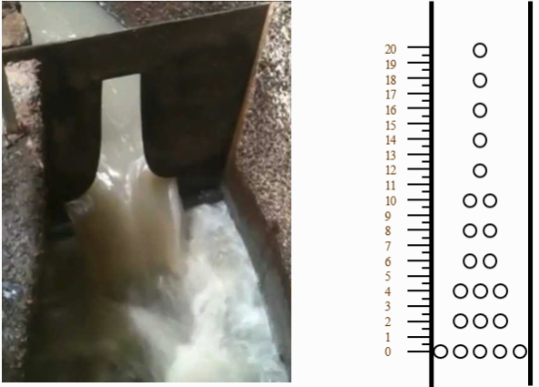

***Figure 2****: The image on the left shows a Sutro weir. On the right is the LFOM’s approximation of the sutro weir’s geometry (Weber-Shirk).*

The Linear Flow Orifice Meter creates a linear relationship between the water level in the entrance tank and the flow out of the entrance tank (Weber-Shirk). It does not, however, control the flow through the plant. On the other hand, it can demarcate the current flow in the plant. Depending on the flow rate the plant has been designed for--in our case 36 L/s--and the number of orifices drilled into the LFOM, the operator can determine the current flow rate through the plant based on the number of rows/orifices submerged in water. Each row on the LFOM can be labelled with respect to its corresponding flow rate such that the operator can identify the flow of water through the plant by observing the water height in the entrance tank. This serves two useful purposes, the first being that the operator has a quick and easy way to measure the flow through the plant, and secondly, that it allows for the Linear Chemical Dose Controller (which is the next component to be described) to automatically adjust the flow of chemical solution into the plant as the flow rate changes. Consequently, the operator would now only need to adjust the flow of chemical solution, or coagulant, when there was a change in the influent water’s characteristics (i.e. turbidity event, increase or decrease in organic matter). This can be achieved by training the operator to conduct a jar test which determines the optimal dose of coagulant by measuring the turbidity of the water and its response to different amounts of coagulants added. The LFOM works based on the linear relationship formed between *Q* and *h* which is a direct resultant of the Sutro weir geometry. In simpler terms, the LFOM maintains linearity between the water height in the plant and the flow through the plant. Alternate weir geometries such as rectangular or v-notch form different relationships between *Q* and *h*, which do not satisfy the linear relationship needed to maintain constant head and dosing. It is important to note that because the geometry of the LFOM only simulates a sutro weir, the component can behave similarly to a rectangular weir if the water level in the tank is too low. This means that the direct proportionality between *Q* and *h* will not be maintained and that the coagulant dose may no longer be accurate. Additionally, if the water level ever exceeds the highest row of the LFOM, linearity will again break down. In this scenario, the entire LFOM will behave like a singular orifice where the proportionality between *h* and *Q* becomes: *h* ∝ *Q2* (this would be similar to having a simple hole in the bottom of a tank).

The Linear Chemical Dose Controller (CDC) is the standard for AguaClara technology. It combines the LFOM with a newly designed and much improved “Almost Linear” Flow Controller. Figure 3 below illustrates the configuration of the CDC.

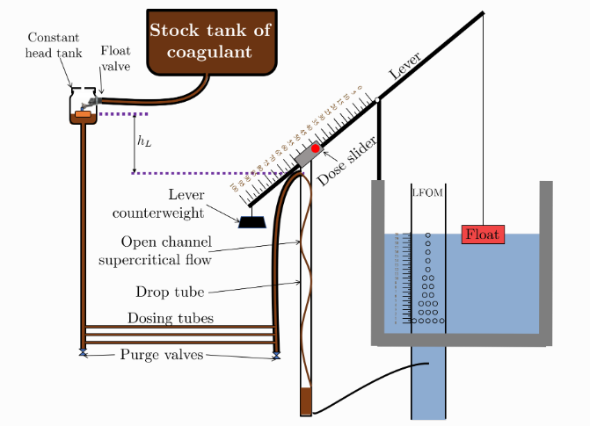

***Figure 3****: Demonstrates the setup and components of the Linear Chemical Dose Controller (Weber-Shirk).*

Similarly to the “Almost Linear” Flow Controller, the CDC features a Constant Head Tank (CHT) for the chemical solutions which is stocked by a tank containing the solution at some elevation above the CHT. The float valve within the CHT ensures that the water depth is always the same in the constant head tank. Newly added to the design of the CDC, are three thin dosing tubes which fix the linearity issues resulting from the singular flexible tube of the “Almost Linear” Flow Controller. These three dosing tubes generate major losses through the system and minimize minor losses resulting in direct proportionality between the plant flow and the driving head through the dosing system. Three short tubes was conceived based on the following two principles: (1) If one short tube were to be used, then the velocity through the tube would be three times as fast as the velocity flowing through three tubes. Since minor losses are proportional to v2 and major losses are proportional to v, this would cause break the critical criterion that major losses must far exceed minor losses through the system to maintain linearity; (2) If one long tube was used in place of the three shorter tubes it would be too long to practically implement. A large diameter tube is connected to the bottom of the CHT to minimize any head loss through the system. A second large diameter tube connects at the end of the three shorter dosing tubes which allows the chemicals to flow out. This large diameter tube connects to a slider and a drop tube which allows for supercritical flow of the chemical solution to leave the dosing tubes. The slider is attached to a lever which relates the water level in the entrance tank to the elevation head measured between the CHT and the end of the dosing tube. This again resembles the “Almost Linear” Flow Controller in that it allows for the flow of chemicals to automatically adjust to the current flow rate in the plant. As the water level rises or subsides--changing with the flow rate--the float will rise and subside with it causing the lever arm angle to change as well. As the lever arm angle shifts, the slider also shifts, readjusting the flow of chemicals into the tank in order to maintain the ideal dose. Water level is tracked using a float, which must be counterweighted since it is typically made out of PVC which is denser than water. The dose slider allows the operator to set the dosing rate of chemicals flowing into the plant similarly to how they would adjust the flexible tube with respect to the appropriate hole in the flow control pipe for the “Almost Linear” Flow Controller. Figure 4 below demonstrates the comprehensive design of the CDC.

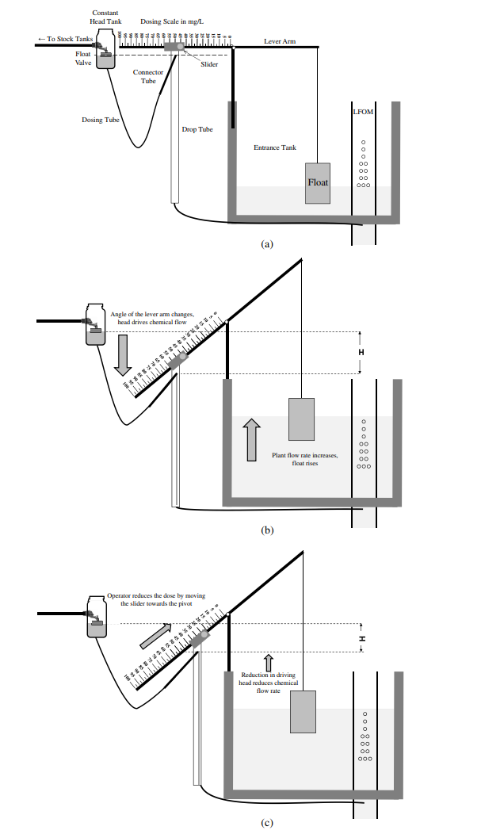

***Figure 4****: As mentioned before, the position of the slider defines the elevation difference between the chemical level in the CHT and the end of the dosing tube. This elevation difference is what determines the flow of coagulant into the tank--greater elevation head greater flow, lesser elevation head lesser flow. The float measures the water level in the plant, which is directly proportional to the plant flow rate as made possible by the Linear Flow Orifice Meter, and subsequently adjusts the flow rate of the coagulant into the water maintaining a constant ideal dose. (Weber-Shirk)*

The CDC provides a chemical flow that is directly proportional to the plant flow rate and makes chemical dosing easier and more accurate. Chemical flow automatically adjusts to plant flow rate changes in order to maintain a constant chemical concentration in the water. This concentration, or constant dose, is set by the operator and adjusts with the float valve. Should water characteristics entering the plant change, the operator can change the dose of coagulant by adjusting the slider appropriately. The lower portion of the lever corresponds to higher doses and the slider is labeled to ensure that the operator can record the dose correctly.

Design of the AguaClara CDC is broken down into a series of steps:

1. Calculating the maximum flow rate, *QMax, Tube*, through each dosing tube diameter, *D*, while keeping error due to minor losses below 10% of the total head loss.
2. Calculate what flow of chemical is needed to pass through the CDC at maximum plant flow and maximum chemical dose, *QMax, CDC*. This is dependent upon the concentration of chemicals in the stock tank.
3. Calculate the number of dosing tubes required if the tubes flow at maximum capacity, *nTubes.*
4. Calculate the length of the dosing tubes corresponding to each available tube diameter, *LMin.*
5. Select a tube length from the array of solutions. Select the longest dosing tube possible such that the tubes will fit inside the plant and cannot be longer than the length of the plant wall it is place along.
6. Select the dosing tube diameter and flow rate associated with the tube length selected from the previous step.

(Weber-Shirk, Paragraphs 72-75)

Currently AguaClara plants feature either Alum (aluminum sulfate) or PACl (polyaluminum chloride) prepared from granular chemicals as coagulants. Figure 5 below shows the kinematic viscosity of each coagulant with respect to concentration of the coagulant prepared from granular chemicals. This graph is important as the kinematic viscosity of the coagulant will affect the chemical’s ability to flow through the dosing tubes.

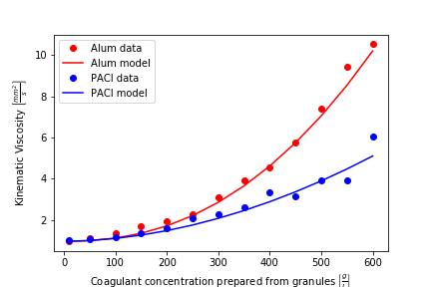

***Figure 5****: Kinematic viscosities of Alum and PACl (Weber-Shirk).*

In summary, a “tank with a valve” design is unreasonable when attempting to design a flow control system for constant dosing, but it may be used to design systems for tank drainage. The Linear Flow Orifice Meter makes the water level in the entrance tank linear with respect to the plant flow rate; it measures flow through the plant but does not control it. The Linear Chemical Dose Controller combines the functionality of the LFOM with the linear relationship between elevation difference and flow out of the Constant Head Tank through the use of a lever. In order to keep chemical dose constant through the automatic adjustment of coagulant and chlorine with plant flow variation, two separate sliders are implemented to give the operator independent control over the dose of each chemical solution with respect to the plant flow rate.

1. **Rapid Mix**

In the AguaClara design, rapid mix refers to processes that take place between the addition of chemical coagulant and the flocculation process (Weber-Shirk 89). In standard systems, rapid mix is required to ensure that coagulant is evenly dispersed throughout raw water so that sufficient interactions can take place with particles during flocculation.

Since this design is specific to empirical observations made by AguaClara engineers, the implications of rapid mix with respect to their observations are what will be detailed. There is a series of events that occur during this process that are laid out as follows (Weber-Shirk 90):

* Coagulant stock solution is added to the influent water
* The water and the liquid coagulant mix via turbulent eddies, or fluid currents that project in opposite directions from the general flow of fluids (Encyclopaedia Britannica).
* Coagulant blends with influent water by diffusion.
* The higher pH of the raw water causes the coagulant to begin to precipitate into nanoparticles.
* Coagulant nanoparticles begin to collect with other coagulant nanoparticles, which in turn attach to dissolved species and suspended particles.

Because coagulants are more acidic, there is a requirement for raw water to be within an ideal pH range. The range accepted by both the AguaClara system and the EPA is listed at 6.5 - 8.5. Values within this range allow for the necessary precipitation of coagulant nanoparticles which are then responsible for particle agglomeration in the flocculation process.

According to the AguaClara textbook, this notion of “rapid mix” is more of an arbitrarily defined period during treatment as opposed to a specific treatment process with a dedicated design (Weber-Shirk). While AguaClara teams continue to work on innovative technologies to enhance and better define this aspect of treatment, the scope of this project will simply be to include the design parameters as they currently exist for the Marwa water treatment plant. In large part, the current requirement is simply to ensure adequate mixing of the coagulant into raw water, which has a direct correlation with flocculation performance.

1. **Flocculation**

The process of flocculation turns inorganic (clays) and organic (viruses, bacteria, protozoa) primary particles into flocs or particle aggregates. This process does not remove particles from suspension, but groups particles together (forming larger particulates and less individual particles), making it easier for them to be removed in the sedimentation process. This is due to flocs having a higher terminal sedimentation velocity than primary particles. The size increase from primary particles to flocs is a thousand fold increase in diameter (billion fold increase in volume). The primary particles are on the order of micrometers, but once they join together to create flocs they are on the order of millimeters. The flocculators are intended to be designed for the particle concentrations they should produce, not the particle concentrations they receive.

In order for flocculation to be successful, collisions between particles--which cause particles to attach to each other--must occur. These collisions lead to particle aggregation which allows the plant to remain low energy and low cost with respect to removing particles and pathogens. In the AguaClara flocculation model, a high velocity and long distance random path through a volume of fluid that’s equivalent to the volume covered by a single particle is assumed. The time required for particle collisions is estimated using the assumption that long distance is the rate limiting step.

The way flocculation is able to turn primary particles into larger flocs that group particles together is by applying a coagulant to the water. The coagulant facilitates primary particles to collide and merge together, creating larger flocs. The particle collision is measured in its collision potential. In the AguaClara system, the collision potential should be around 37,000 (this is a dimensionless value). The collision potential is obtained by multiplying the average fluid shear by the residence time of water in the flocculator.

Another important measurement in the flocculation process is the energy dissipation rate. The energy dissipation rate is related to how viscous the fluid is. The more viscous the fluid, the more energy it takes to make the fluid flow fast, therefore the energy dissipation rate is higher. It can also be thought of in terms of head loss, the total energy dissipated in the flocculator is the total head loss in the flocculator. The energy dissipation rate is simply gravity times the head loss over the residence time of the water in the reactor.

In the flocculation process, it is important to create headloss. Headloss can be generated from both major and minor losses, but the AguaClara flocculator design focuses on generating headloss with minor losses. Major losses to create headloss in flocculation are only typically used in very low-flow situations such as in a lab-scale setting. Since there will be a higher flow of 36 L/s minor losses are used in the design to create headloss.

In the AguaClara design, minor losses are created by using baffles. Baffles create flow expansions which allows for minor losses to occur. The baffles in the flocculator are obstructions in the channel that force the flow to make a 180 degree direction change. The baffles used are made of plastic sheets. All of these baffles in each channel are connected, creating a baffle module. The AguaClara flocculators are vertical hydraulic flocculators. This means that the baffles cause the flow to move vertically up and down. This design was chosen over horizontal hydraulic flocculators because they take up less space which allows the plant to be smaller and therefore cheaper. The minor loss coefficient, K, for flow around a single baffle is calculated by the area out of the baffle divided by the entire area, minus one, and then all squared. The Kbaffle value used to design all AguaClara plants is assumed to be 2.56.

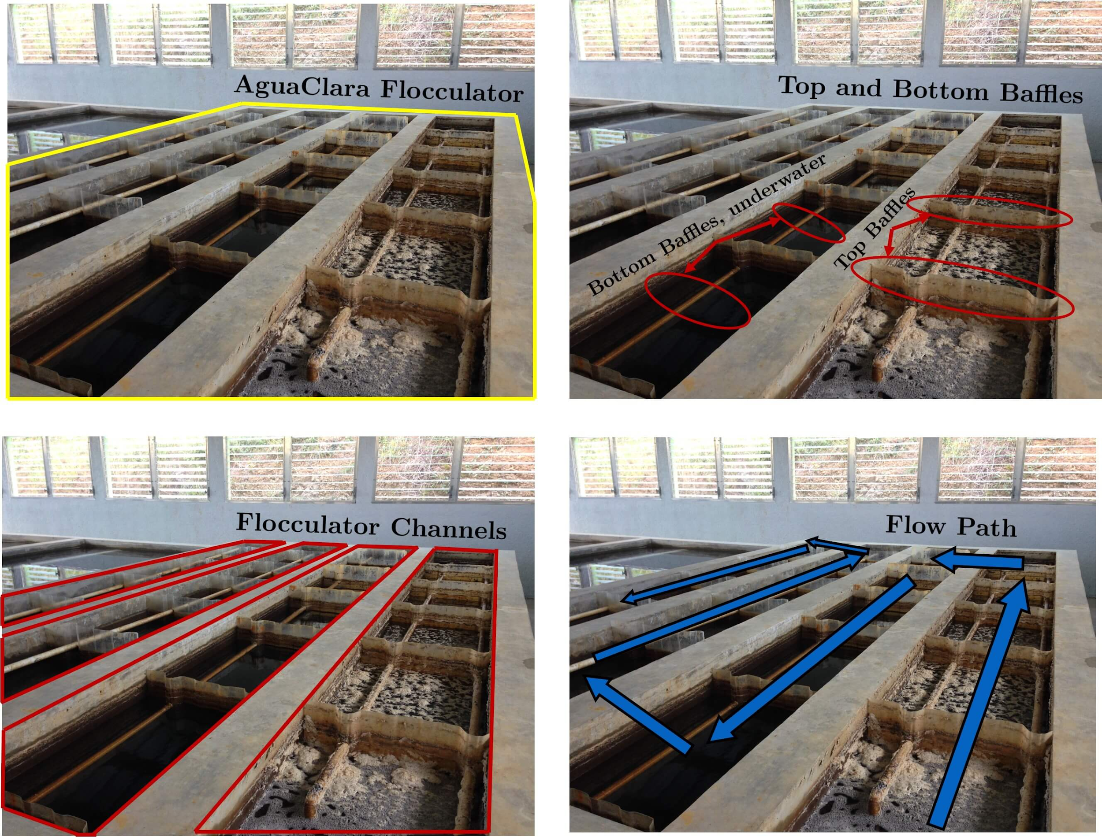

***Figure 6****: Fig. 90 Clockwise from the top left the images show: the outline of the entire flocculator, some top and bottom baffles in the channels, the 4 flocculator channels in this flocculator, and the flow path of water through the flocculator* (Weber-Shirk).

To optimize efficiency the ratio of distance between flow expansions and the spacing between baffles must be between 3 and 6. In order to maintain this ratio as well as the energy dissipation rate and collision potential, obstacles must be added in addition to the baffles. The obstacles used are half-pipes that contract the flow of water after it expands around a baffle and before it reaches the following baffle. The obstacles helps to create extra head loss in between the baffles. As shown in the calculations in Appendix A, only 1 obstacle per baffle space is needed.

Figure 7 below shows the baffles and obstacles that facilitate flow expansions in the flocculation system. This flocculator is a vertical flocculation system, meaning the water flows up and down between the baffles and obstacles. In this design it will go through 2 channels. The flow of water through the flocculator can be seen in Figure 8 below.

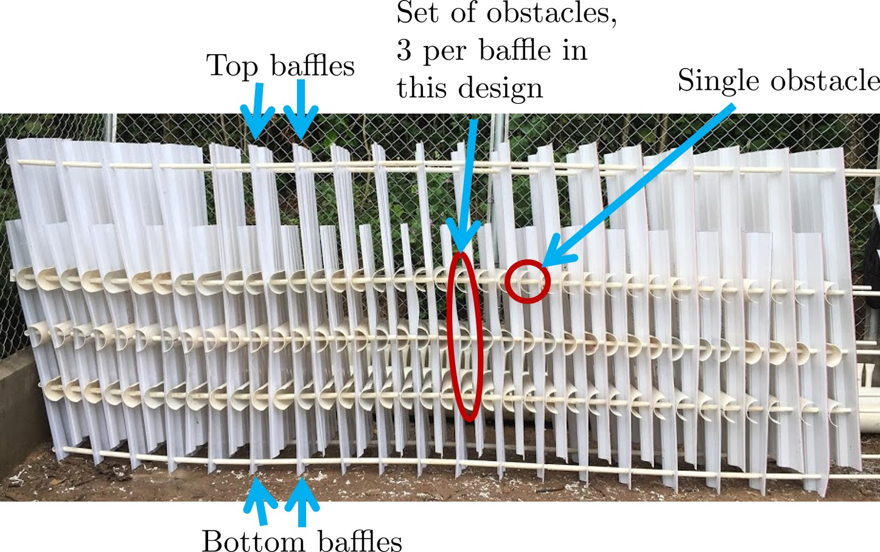

***Figure 7****:Obstacles are added so that the flow continually contracts and expands. Additional obstacles are needed for low flow plants where the spacing between baffles is small relative to the flocculator depth* (Weber-Shirk).

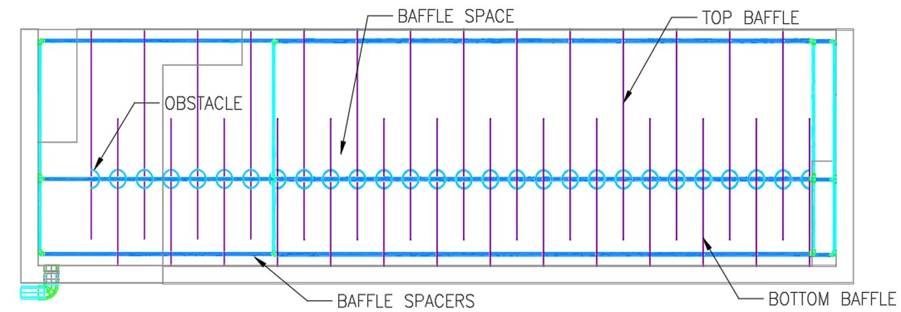

***Figure 8****: Profile view of the flocculation tank. The water enters from the left and flows up and down the baffles and around the obstacles.*

**Designing the Flocculator System**

With the help of the equations outlined in the AguaClara Textbook, design calculations can be performed.

The input parameters are all given or known values. The flocculation headloss, collision potential, and height of water at the end of the flocculator are constants for every AguaClara plant. The flow rate is also an input variable, which is 36 L/s for this plant. The last two input variables are the length of the flocculation tank based on the sedimentation tank and the minimum width of a channel. This will be used to calculate the actual flocculator length and width.

1. Input parameters:
   1. Head loss, hL floc =40 cm
   2. Collision Potential, Gcsθ= 37,000
   3. Plant Flow Rate, Q=36 L/s
   4. Height of water at the end of the flocculator, H= 2m
   5. Maximum length of flocculator channel based on sedimentation tank length, Lmax, sed = 6m
   6. Minimum width of a single channel based on width of an average human hip (so people can access it), Wmin, human = 45 cm

Next the average velocity gradient can be calculated from the input variables, this is the change in velocity over the flocculation system. The hydraulic retention time and flocculator volume are then calculated. These are defined as the time it take the water to go from the start to the exit of the flocculation and the volume of the flocculation tank respectively.

1. Calculate parameters:
2. Average velocity gradient, Gcs
3. Hydraulic retention time, θ
4. Flocculator Volume Vfloc

After, the physical dimensions of the component are calculated. This includes the length, width, and number of channels in the flocculator.

1. Calculate Physical Dimensions:
   1. Channel length, Lchannel
   2. Amount of channels, nchannels
   3. Channel width, Wchannel

Lastly, the hydraulic parameters are calculated. This includes the distance between baffle/obstacle induced flow expansions, which in this case will be ½ the water height, since only 1 obstacle was calculated per baffle space, (which is the next thing calculated). And lastly the space between each baffle is calculated.

1. Calculate Hydraulic Parameters:
   1. Distance between baffle/obstacle induced flow expansions, He
   2. Amount of obstacles per baffle space, nobstacles
   3. Baffle spacing/ distance between baffles, S

***Figure 9****: Fig. 102 Layout of flocculator and sedimentation tanks that was adopted starting with the 2nd AguaClara plant in Tamara, Honduras in 2008.* (Weber-Shirk).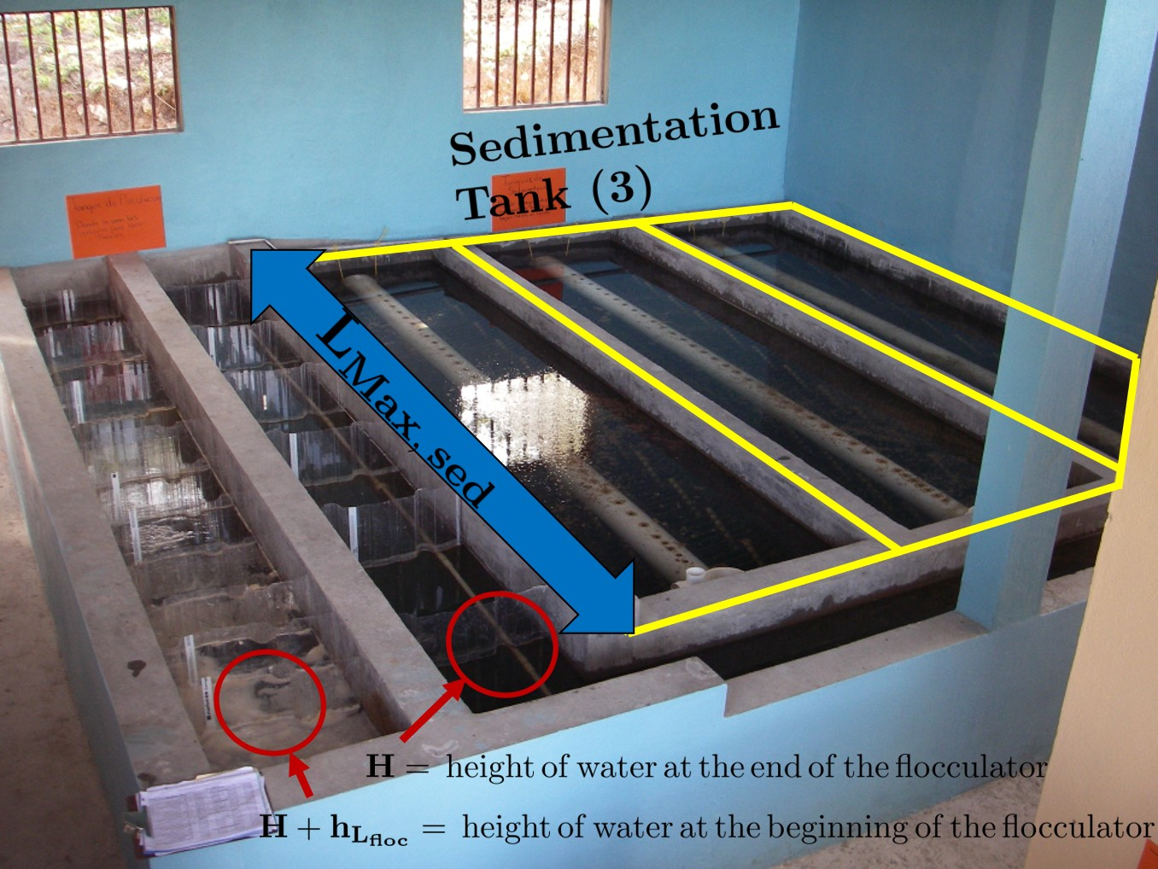

[All information is referenced from Weber-Shirk, rewritten in own words unless specified otherwise]

Calculations for the flocculation design are located in Appendix A.

1. **Sedimentation**

Sedimentation is a standard unit process in water treatment in which agglomerated flocs from the flocculation process are settled out via gravity. Sedimentation plays a big role within the scope of the plant because as sedimentation becomes more efficient, more solids can be removed. Removing more solids early on means that the sand filter does not become overloaded with solid particulates. In the end, this results in less water required for the sand filter backwash (Weber-Shirk). An overview of the sedimentation tank design can be seen below in Figure 10.

For the Marwa water treatment plant to be successful, three things need to be able to happen. First, flocculation needs to take place to an adequate degree such that the flocs that end up suspended in the raw water can settle out. This means that they need to be large enough, and they need to be able to settle somewhere. Secondly, flocs that are settling out need to be able to move from a settling point to a lower section of the tank. Since the goal is to eventually remove the agglomerated floc particles from the water, there needs to be a system in place where these particles can be removed from the water stream. Finally, once those flocs have collected at the bottom of the tank, there needs to be a method in place to remove them from the system (Weber-Shirk).

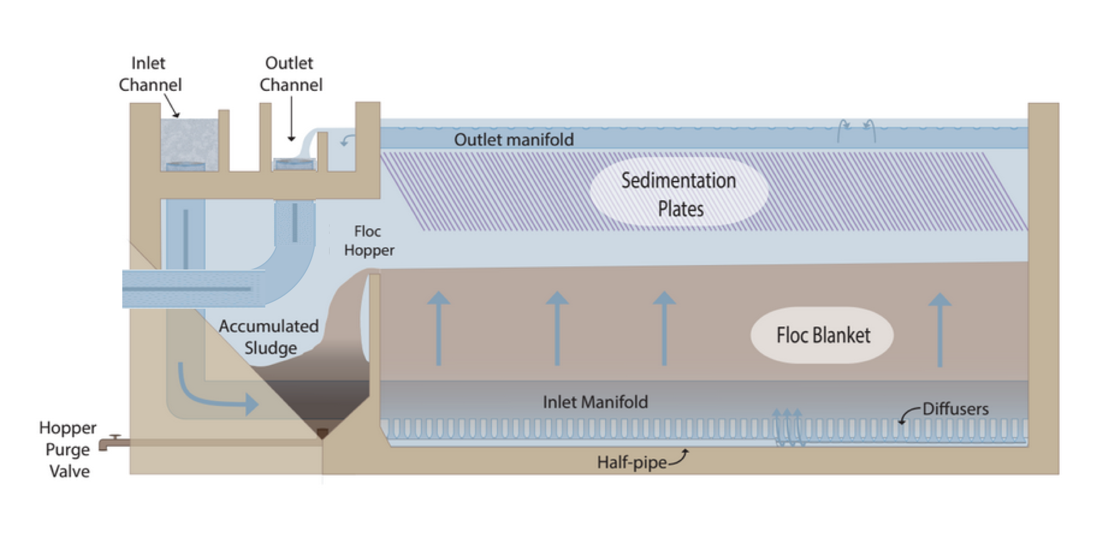

***Figure 10****: Overview of the sedimentation tank (Weber-Shirk).*

The sedimentation process begins just after flocculation. The water is led through an inlet channel that distributes the flow into several different sedimentation bays. For the purposes of preventing settling in the inlet channel, water is flowing at a minimum velocity of 0.15 mm/s. While the goal is to maintain equal flow distribution into each sedimentation bay, this is not always the case. AguaClara uses the term “bad head loss” to refer to situations in the design where circumstances lead to unequal distributions of flow in parallel treatment paths. In this case, the inlet channel diverts the most water to the last orifice in the path. This is undesirable, but currently unavoidable. The inlet channel with its six adjacent orifices can be seen below in Figure 11.

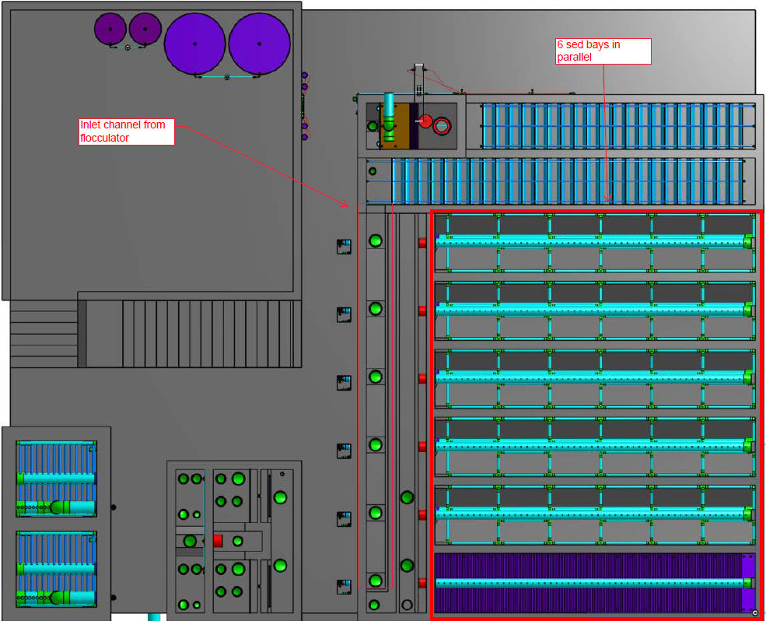

***Figure 11:*** *Top view of plant (OnShape).*

The motivation for having multiple sedimentation bays is that there is a flow constraint based on other design parameters, mainly upflow velocity. Thus, the number of bays ultimately depends on the flow rate of the desired plant. Redundancy is also considered when thinking about the desired number of bays. Having redundancy means being able to cut flow to a certain bay as needed in case maintenance needs to be performed. The orifices in the inlet channel are designed such that they can be plugged easily to shut down flow to a bay in order for maintenance to take place. If all of these orifices are plugged, water can be bypassed to a waste stream. This contingency is in place in the event of maintenance requirements or, an event which leads to a poor dosing of influent water which leads to bad flocculation. If this water is allowed to run through the sedimentation process, then the effluent quality will be poor. But if the orifices are plugged, the poorly flocculated water can be sent to waste.

The 36 L/s design uses 6 sed bays in parallel. The bottom sed bay includes the sedimentation plates to show what a finished view would look like without water. The other 5 sed bays omit these details in order to show the inner workings of the bay.

After water enters one of the six orifices in the inlet channel, it drops a few feet, then follows a smooth 90 degree bend to become once again parallel with the ground. This parallel section of pipe is called the influent manifold - shown below in Figure 12. Water flows through this pipe and exits through evenly spaced orifices on the bottom of the manifold. Protruding from these orifices are small diffuser tubes (Figure 13), perpendicular to the manifold, that are flattened at the end. These diffusers in line with one another create a line-jet effect for exiting water. These diffusers are the only exit for the water, as the end of the influent manifold is capped.

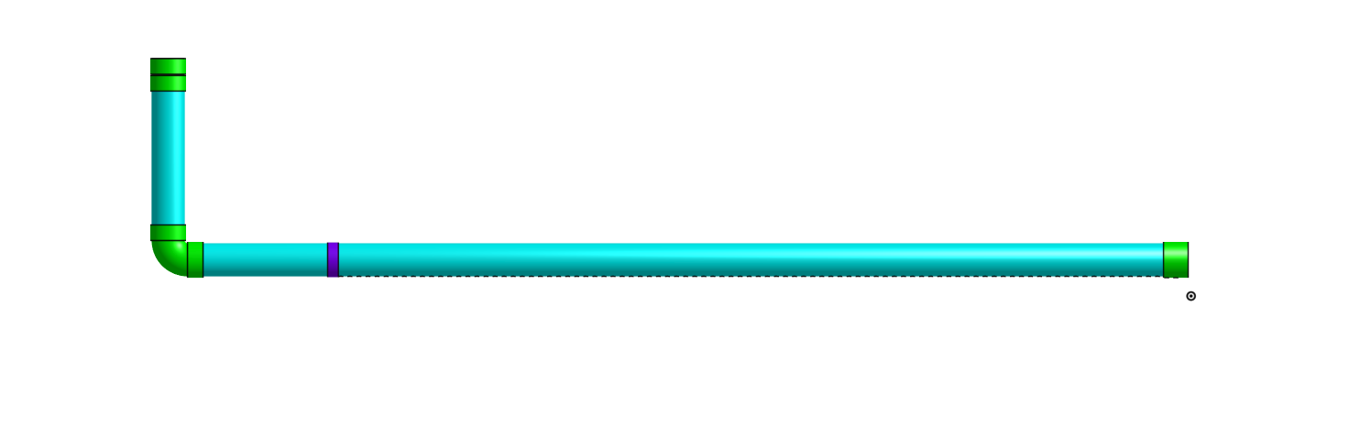

***Figure 12:*** *The influent manifold. Water enters from the inlet channel (top left) and flows through the manifold. Flow exits by being evenly distributed through diffusers (shown in Figure 13 below) that are connected to the influent manifold (OnShape).*

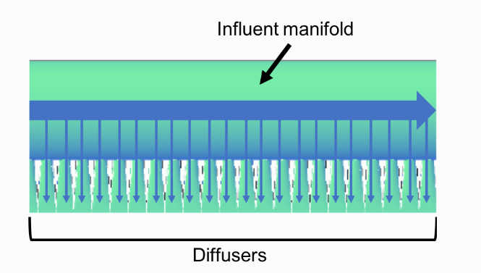

***Figure 13:*** *Influent manifold and diffusers. (Weber-Shirk).*

These diffusers are in place because the jet effect created allows for a velocity vector with solely a vertical component. If, for example, there were only orifices on the bottom of the manifold, there would be a horizontal velocity vector which would thereby push floc particles straight to the top of the sedimentation basin, which is the exact opposite of the desired outcome. Ultimately, the water should flow upwards. To make this happen, a half pipe is installed underneath the diffusers. This is referred to as a “jet reverser”. Effectively, it takes the downward flow from the diffusers and redirects it upwards. This begs the question: why reverse the flow in the first place? Why not just have the diffusers pointing upwards? The AguaClara textbook notes a few reasons for the use of the jet reverser:

* By pointing the diffusers downward, the potential for clogging the orifice/diffuser is eliminated.
* By pointing diffusers downwards, the flow is allowed to circulate throughout the width of the sed bay. If they were to point upwards, the width of the sed bay would not be utilized.
* Flocs are kept suspended by the force of the reverse jet. This allows for the formation of a floc blanket, and ensures that no flocs settle out before they are supposed to. It also prevents sludge build up from occurring, since it is resuspended by the force of the reverse jet.

With the resuspension of the flocs, a floc blanket is formed. This can be seen below in Figure 14. AguaClara has concluded that the formation of the floc blanket can reduce turbidity by up to ten times the normal reduction (Weber-Shirk). This blanket is maintained at a specific level with the application of a weir called the floc hopper.



***Figure 14:*** *The bottom portion of the sedimentation bay overview (Weber-Shirk).*

There are several benefits to having the floc hopper as a control weir for flocs. First, it creates a self-sustaining cleaning system where an operator simply needs to open the purge valve from time to time. The floc blanket stays at a constant level in the main section of the sed bay because it spills over the weir into an area where sludge is allowed to accumulate. Since the flocs are more dense than water, they are the particles spilling over the floc hopper. If operated properly, manual cleaning will only need to take place once every three to six months - and this will mostly be to clean the sedimentation plates (Weber-Shirk). This involves inserting pipe plugs into the influent manifold pipes and allowing water to overflow a weir in the influent manifold. Baffles are then removed and an operator is able to enter the sed bay (the minimum width of the sed bays and floc tank is set at a value deemed the minimum width for a person to be able to enter the tank). Once inside, any cleaning desired can be done by shoveling/scraping any residual floc/sludge.  
  
The hopper purge valve is what actually removes collected flocs from the sed bay during operation, of which the frequency is generally determined observationally by operators. There is not yet an effective means of judging how often this is, so it is up to operators to determine what works for their system (Weber-Shirk).

Other components critical to the success of the sedimentation process are the plate settlers. These plates are distributed and angled such that flocs that are driven up with the upflow velocity (~1 mm/s) of the water will collect on the plates and agglomerate, eventually leading them to fall back down to the floc blanket. The plates are positioned 2.5 cm apart to prevent “floc rollup” (where flocs meet a force balance of gravity and drag forces, which leads to them not settling downwards but rather staying still), and are angled at 60 degrees. These two parameters are standard for the AguaClara design and are mainly in place to optimize tank depth and settling efficiency. There is also a small factor of safety applied for the plate spacing so that floc rollup does not occur. This ensures that floc will indeed settle out as they agglomerate to collect in the floc blanket (Weber-Shirk).

With the flocs separated and settling, the water is ready to exit the sedimentation bay. The method of exit is similar to the method of entry. In this case, water flows into a manifold that is located at the top of the sedimentation bay (Figures 15 and 16 below). This manifold is above the plate settlers, but below the surface of the water. Where the influent manifold had drilled orifices on the bottom with diffusers, the effluent manifold has holes drilled on the top of the pipe *without* diffusers. Diffusers are not needed for the effluent manifold because the velocity and velocity direction do not need to be controlled (Weber-Shirk).



***Figure 15:*** *The top of the overview of the sedimentation bay. The outlet manifold runs along the top (yet below the surface of the water) (Weber-Shirk).*

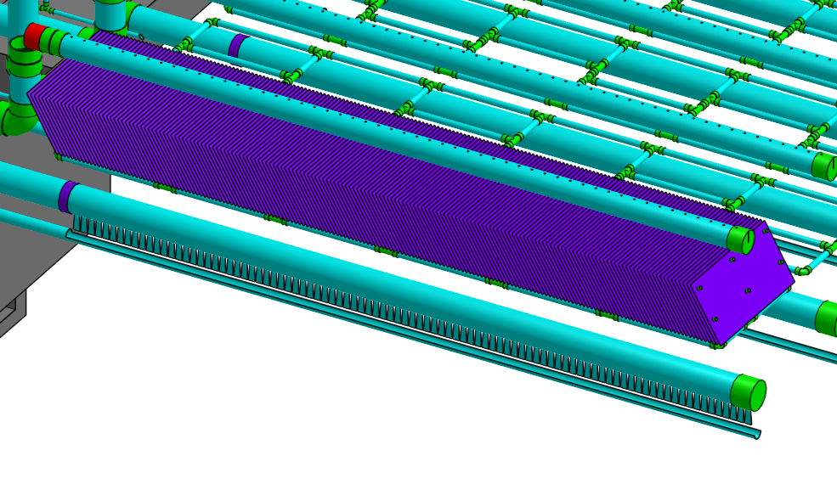

***Figure 16:*** *Open view of the sedimentation bay. Effluent manifold (top, with visible orifices); plate settlers (purple); influent manifold (below settlers, capped with green pipe end); diffusers (protruding from influent manifold); and jet reverser (half-pipe under diffusers) (OnShape).*

As water enters the effluent manifold, it flows back towards the inlet channel where it came in. Water flows out of the effluent manifold into a channel near the inlet channel (Figure 17 below). The water then flows over a weir into the outlet channel. The inlet channel and the outlet channel are separated by a third channel that serves as the overflow in the case of bad flocculation, mentioned previously. There are only two orifices located in the outlet channel, and both of these lead to the sand filter.

The importance of the weir in the outlet channel cannot be overstated. Called the “exit weir” in the AguaClara design, this flow control structure controls water elevation up to the previous control structure, which is the linear flow orifice meter back in the entrance tank. This means that this weir effectively controls flocculation and sedimentation water height. Thus, this weir must be carefully constructed such that it is the right height, and it is level (Weber-Shirk).

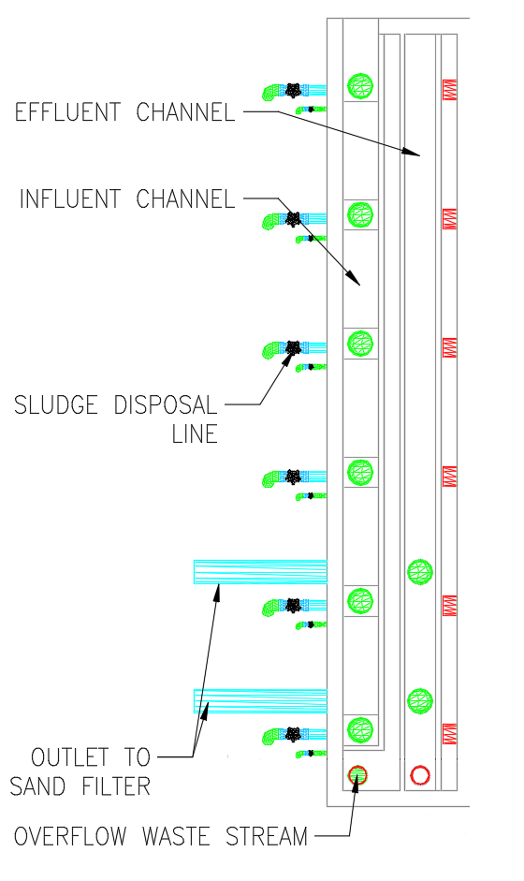

***Figure 17:*** *Top view showing functions of different objects in inlet/outlet channels.*

The 10 State Standards for sedimentation require residence times up to 4 hours for the design of a sedimentation process. The innovations designed by AguaClara can cut this time down, in some cases, to as low as 24 minutes. After finishing a trip through sedimentation, water is ready for the stacked rapid sand filter.

1. **Filtration**

The last step in the treatment process is filtration. Flocculation and sedimentation are important steps that facilitate the removal of most primary particles. Filtration helps to remove any remaining particles. It should be noted that filtration alone would remove far less primary particles than it would following flocculation and sedimentation. In the treatment plant, stacked rapid sand filters (SRSF) will be used for filtration. Traditional methods of filtration using rapid sand filters require an initial backwash of water to wet the sand. They also require pumps. In 2010, AguaClara invented a stacked rapid sand filter that eliminates the need for backwash pumps. These stacked rapid sand filters are what will be constructed in the treatment plant.

These filters use 6, 20-cm deep layers of sand that are stacked vertically, with a total depth of 1.2 meters. The filters use the same flow rate for backwash and filtration. Settled water is used as backwash, which eliminates the startup problem associated with not having a backwash source. Due to the treatment plant’s flow rate being 36 L/s, it will use an open stacked rapid sand filter system.

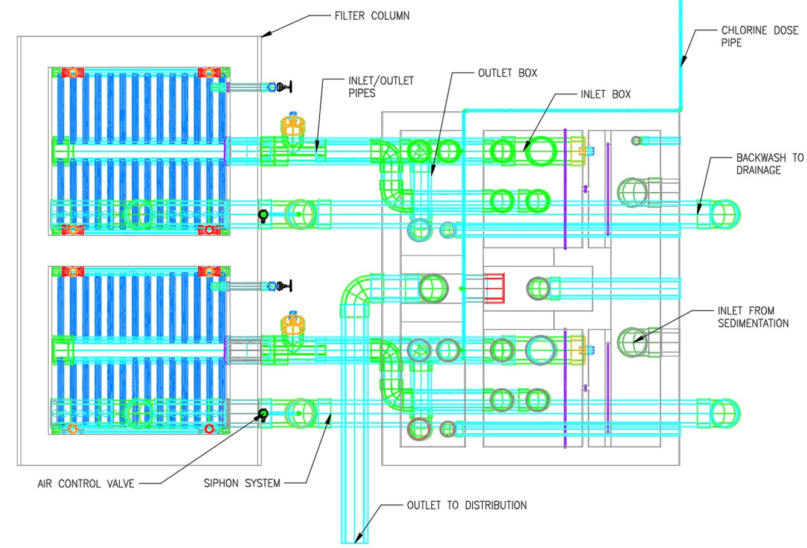

***Figure 18:*** *Top view of the Stacked Rapid Sand Filter with all key components labeled.*

An important factor in the design of the filters is the porosity of the sand. This is dependent on both the geometry of material in the control volume, as well as the particle size of the sand. Under ideal conditions, all particles would be the same size, meaning the uniformity coefficient (UC) would be one. The backwash step in the process causes the porosity of the sand to change. This is because the sand is filled with a volume of water causing the sand bed to expand.

Another important factor in the design is the headloss from the system. The headloss through the system is what determines the velocity required for backwash. Headloss is a design parameter, and other design values are dependent upon this value in order to be calculated. The most important parameter is the fluid velocity. Due to the sand, the velocity at the top and bottom aren’t the same, this is important because it is a property of how porous the sand is.

In the design, six layers of sand are stacked, there are four inlets, and three outlets which are all in use during filtration. During backwash only one inlet is used and the backwash water is discarded through a separate manifold. As a parcel of water traveling in the filter, the first part of the filter is the inlet box. The inlet box is a shallow box with four holes in the bottom. The holes lead into four pipes which lead into different levels of the sand filter. At the outlet of each of these pipes into the sand filter is a structure designed to spread the flow over the entire footprint area of the filter. These structures have slots which allow water out of the inlet pipes into the sand bed. Across a layer of sand from the inlet is an outlet pipe in the same shapes as the slotted pipe inlets. Water passes into the pipes and up to the filter outlet box where it only needs to be chlorinated before being distributed.

(Weber-Shirk)

The height of the standard filter layer is determined by the maximum value between the defined layer height, outer radius of the trunk and the minimum filter trunk spacing, the outer diameter of the fitting of the trunk, and the fernco outer diameter. The height of the bottom filter layer is determined by the maximum value between 1, the defined layer height, the outer radius of the trunk, the outer radius of the backwash trunk, the minimum filter trunk spacing, the sum of fittings outer radius for the trunk, the backwash trunk, and the average of the fernco outer diameter.

The backwash through the filter occurs due to a siphon system that initiates it. Two things have to happen to ensure success in the system: (1) the backwash is able to be initiated at any point in time, and (2) the siphon can prevent the backwash. One issue with this design is the disposal of the backwash created. In AguaClara plants, the backwash is discarded through a separate manifold and just released outside with no other disposal considerations.

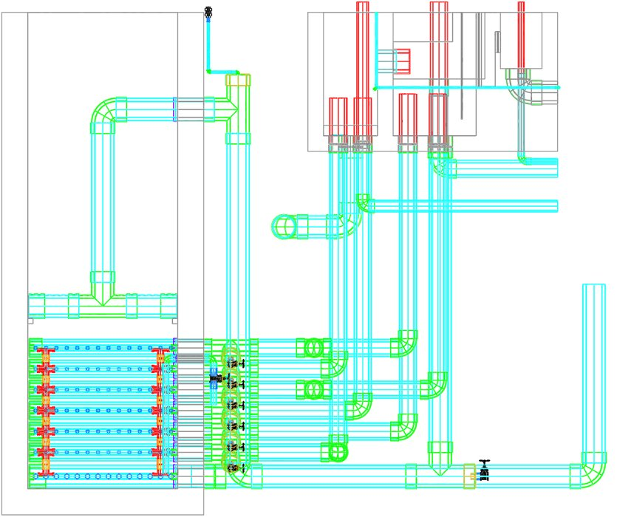

**Figure 19:** *Profile view of the Stacked Rapid Sand Filter. Water flows through the 4 entrance pipes and filters through the sandbox till the water level in the box overtakes the level in the inlet box, then the water is sucked out though the 3 exit pipes and piped to the outlet box where it is chlorinated and leaves through the exit pipe to distribution.*

**III. Cost Estimate**

In a meeting with Dr. Monroe Weber-Shirk from Cornell, Monroe stated that a general estimate for construction costs on AguaClara costs can be estimated by the following equation:

(# L/s of desired plant) * $8,000/L/s + $100,000 = Cost of plant in american dollars.

For a 36 L/s plant:

(36 L/s * $8,000) + $100,000 = $388,000 USD.

At 2344 Tzs per 1 USD, this would translate to 909,627,200 Tanzanian Shillings.

This is, of course, a very generalized estimate and does not make the special considerations needed for building such a system in Tanzania. With this in mind, correspondence with Cornell students is ongoing in hopes of learning how the non-profit partner of Cornell (Agua Para el Pueblo) creates cost estimates based on material quantities. Using a dimensions list provided by an AguaClara design tool and AutoCAD drawings, a materials estimate was drafted to reflect the required materials for construction of the treatment portion of the plant (i.e., concrete quantities were left to the treatment structures team). This materials list is split up by process, and is available in Appendix B.

**IV. Remaining Work**

While much has been learned about the AguaClara treatment plant design, there are still many details that must be investigated and questions to be answered before this system is ready to be installed in Tanzania. This section hopes to inform future members of the treatment team the resources available to them, questions that still remain to be answered (not a comprehensive list by any means), and the next steps towards completing the design so that they can hit the ground running in Autumn 2019. The team also hopes to outline work that they will continue to prepare and complete before and after travel to Tanzania. One of the main goals of our team is to better organize the results and progress of this past year so that future teams can reliably access the knowledge gained over the past two semesters and are able to utilize this knowledge going forward. We hope that this document has provided valuable insight towards the AguaClara design and that it clearly communicates the major components that comprise the system, but would like to offer the opportunity to any future team members to reach out with questions concerning the design.

1. **Available Resources**

AguaClara Cornell has been an invaluable resource to the team this year. Without their help and expertise, none of the progress and redesign of the treatment system would have been possible. The team this year strongly recommends utilizing their knowledge as much as possible--something we could have done more of--and is providing numerous resources related to communication with AguaClara for future teams to take advantage of. The partnership Ohio State and Cornell have formed is extremely exciting because it represents the development of knowledge-sharing communities that are dedicated towards serving and improving quality of life for people all around the world. As we learn from Cornell, we also offer unique perspectives and ideas that they can learn from. Through such collaboration, we hope and expect to see much quicker progress being made towards helping communities in need. More importantly, we hope to see the quality and consistency of the aid provided to these communities continue to improve.

As for resources, the main form of communication with AguaClara over the past semester was through email. Yitzy Rosenberg and Oliver Leung were two members of the AguaClara team with whom communications regularly transpired. Understandably, team members change from year to year, but email communication is a reliable and fool-proof way of reaching out to members of the AguaClara team. Each team that comprises the AguaClara organization and their respective members are listed on AguaClara’s team website: <http://aguaclara.cornell.edu/index.html>. One resource that was not utilized to much extent was AguaClara’s communication platform, Slack. Slack is AguaClara’s main form of sending notifications, updates, and events to their team. We were added to their team line, but didn’t have the opportunity to use this resource too frequently--it was also a new communication platform that we didn’t fully understand. It would be useful to investigate and figure out how to use this platform more consistently as it would allow for quicker communication with AguaClara in general, but also with more team members too. This would allow for more members of AguaClara to be in the loop of what we are doing as well as add the potential for more complete answers to any questions we may have. We can request for more members to be added to the AguaClara Slack channel whenever needed. One thing that is important to remember in all communications with AguaClara is that they are providing assistance to us voluntarily. This means that they may not be able to answer every question we have, or that it may take time to receive particular answers as they are just as busy as us! This is completely understandable, and we should respect their time and their ability to assist us. Future team members will be forwarded all email communications with AguaClara thus far as a means of reference and documentation.

Another essential resource that was generated between Ohio State and Cornell this semester is the AguaClara Information Accessibility Document (IAD). This document is a collaborative posting board on Google Drive in which we can post questions about the system or any trouble we are having with locating AguaClara information, and in which they can update responses live-time. One of the main requests from AguaClara after our visit in December was that we help them understand what information is difficult to find/access so that they can improve the dissemination of their knowledge on designing sustainable water treatment plants for developing communities. AguaClara is completely open-source, which means they want their information to be accessed and utilized and we get to play an important role in helping them improve the way their information is presented to outside viewers. This document will be shared with future team members so that information sharing can continue between our two universities.

AguaClara also utilizes a coding-based platform known as GitHub. To locate this resource, simply search in Google, “aguaclara github”. AguaClara is currently working on finalizing a design tool that would allow any user to input a few desired parameters, such as plant size (i.e. 36 L/s), and receive all relevant output for constructing that specific water treatment plant. Their code for this program is still being written, but it would be worthwhile to continue exploring how the code runs so that our design can be verified with the new design tool when completed. Since we do not often utilize GitHub in the CEGE department at OSU, it can be a relatively confusing site to understand and navigate. For new team members, spend some time trying to familiarize yourself with the site and what information is available there. Refer to the Information Accessibility Document (IAD) for questions already asked about how AguaClara uses GitHub and how to navigate the site. GitHub is a well-known platform amongst coders, so it may also be useful to recruit new team members from the CSE program here at OSU in order to make better use of this platform. An old version of AguaClara’s design tool can be located at the following link as well: <http://designserver.cee.cornell.edu/Designs/EtFlocSedFi/7667/36Lps/Index.html>. You can adjust the plant size being designed for by changing the number in the URL (i.e. 20Lps, 24 Lps, 40Lps, 50Lps, 60Lps).

A majority of this report was written using AguaClara’s textbook: <https://aguaclara.github.io/Textbook/>. It is highly recommended that in addition to reading this report, all new team members read through this textbook--it was monumental in helping us understand the construction and processes of AguaClara’s design. Readers will find a lot of overlap between this document and the textbook, but it will be useful for helping new members retain information about how the system operates as well as afford them the opportunity to develop new questions related to the system that may need to be answered. Dr. Weber-Shirk has numerous resources further explaining the components of AguaClara’s design in depth. Some of these resources have been uploaded to BuckeyeBox (search “HOW RAPID SAND FILTER WORKS”, “HOW CDC WORKS”), but can also be found through sites like ResearchGate and searching for “Monroe Weber-Shirk”.

AguaClara also uses an online CAD software known as OnShape. This platform has a beautiful 3D model of the plant design and helps in visualizing the final product to be installed in Tanzania. Access to the OnShape file will be provided to future members. Forewarning, one of the only drawbacks to OnShape is the fact that it is a cloud-based platform which causes it to run very slowly.

Lastly, in the spirit of university collaboration, Patrick has been in contact with faculty at Clemson University. The hope is that a similar knowledge-sharing, collaborative relationship will be formed with the team at Clemson between our university and between Cornell, in order to further all our knowledge bases and move closer towards the goal of improving quality of life for all people. Be sure to follow up on this effort!

1. **Questions to Consider**

The following are questions to consider regarding the treatment plant and its constituent components. These questions should be further investigated and may need input from AguaClara as to how they have addressed these issues in other plants they have built. This is not a comprehensive set of questions; there are still many new questions that will arise and that will need to be addressed.

1. **Flow Control and Measurement/Entrance Tank:**

* How often should the operator test for turbidity events?
* What happens when linearity breaks down within the system (i.e. when the water level is too low and acts like a rectangular weir or too high and acts like a singular orifice)? How does this affect the treatment and addition of coagulant? Only temporarily until linearity is restored? Permanently? Is there any way to control the flow such that linearity never breaks down? Is there any way for the operator to restore linearity quickly in the event that either of the scenarios described above occur?
* Is there ever any chance of the entrance tank overflowing?
* Where exactly do the drop tubes and chemical injection point connect at? Unclear based on current AutoCAD drawing and OnShape file. Lever arm is currently floating in space and drop tubes end several feet off the ground.
* How big do the coagulant/chlorine stock tanks need to be? How much stock is required in tanks in order to maintain constant head in each CHT? How often do these stock tanks need to be replenished?

1. **Flocculation:**

* There is a large empty volume where the LFOM transitions and dumps water into the flocculator; is this where chemical injection occurs? Should additional baffles or obstacles be installed here or is the space necessary to allow water elevation head to develop pushing the water through the subsequent baffles?
* Similar to the entrance tank, how is overflow prevented in this system?

1. **Sedimentation:**

* What will cleaning of the floc hopper entail? Drainage and shutdown of system? How long does cleaning of excess sludge take? What does proper operation look like in order to reduce number of cleaning events?
* Are there appropriate materials in Tanzania that could be made into the plate settlers? Are these plates something specific that AguaClara/APP has manufactured for this specific purpose?
* What is the distinction between the modules and the module spacers? Is one contained within the other? How are these secured in the sed bays?
* How is the floc blanket maintained in plants that do not operate continuously (i.e., our plant)? The AguaClara textbook notes that the floc blanket model is hard to sustain for plants that aren’t operating 24/7.

1. **Filtration/Chlorination:**

* How often is backwash run? What time is backwash run?
* There is another discontinuity in the AutoCAD drawing where the chlorination line that inputs the chemical into the rapid sand filter does not connect to the chlorine stock tanks. Need to figure out the continuation of this line.
* What is the height of the exit pipe out of the rapid sand filter? Is it above grade? The structures team had to redesign the support system for the sedimentation tanks because these tanks would be elevated in order to put the bottom of the SRSF at grade. The SRSF exit pipe was needed to be at grade so that it was easily accessible in the event that it needed to be replaced, or in the event that it began leaking it wouldn’t flood the surrounding area. If the exit pipe is above grade then maybe we can reposition the sedimentation tanks back on grade which would require less structural support. This begs the question however, if the SRSF is below grade, would we need to worry about leaks again? How would we maintain/replace sand in filter? How would we replace pipes/sieve pipes in the event they were damaged if the SRSF is below grade?
* How does the siphon system in the SRSF work?
* Does expansion of sand during backwash ever cause any uplift on the pipes in the SRSF? What structural issues does this create?

1. **Operations and Maintenance:**

* What happens at the end of plant operations for a single day? Water drained or left in tanks until process resumes? Would water left in tanks be considered settled water that could be used to backwash the system at the beginning of the day before new water is treated?
* What will operator training look like?
* How long will operators need to be at the plant? One extended shift? Multiple operators swapping shifts? Multiple operators at the plant at a single time?

1. **Next Steps**

Remaining steps for future teams to consider are summarized as follows:

* Detailed cost estimate
* Continued development of construction documents
* Additional calculations for AguaClara design components and design verification by AguaClara
* Additional development of plans for plant operation and maintenance

A detailed cost estimate and materials list is still required for the treatment plant. The AguaClara plant was specifically designed with the intention of being a sustainable solution to the water crisis for many underdeveloped communities. This means that all technology within the plants was designed to be easily accessible, locally sourced material so that if a component were to break the community could easily replace this part and continue operation of the system. The team this year has provided a rough estimate of the “total” cost of the treatment plant based on a relative approximation offered by Dr. Weber-Shirk as discussed above, but this will be need to be revised to comply with the materials list for components of the plant and their cost locally in Tanzania. Furthermore, the materials list may need to be adjusted in general to meet the locally-sourced sustainability requirement for Tanzania. This means investigating what resources the community has ready-access to and making sure these materials are suitable for functioning as specific system components. Preliminary materials sheets have been provided for each system component in Appendix B in order to set future teams on the right path. These materials lists will likely need double-checking and revision based on quantity changes, material changes, etc.

Further development of construction drawings will also be required of future teams. A preliminary set of drawings was developed this year in order to help the community visualize and understand the new design of the treatment plant. Additional views, sections of the system may be required to further clarify system processes or procedure for component construction. Detail drawings of more specific process components such as the sludge disposal line, trash rack, coagulant and chlorine stock tanks, sand filter siphon, drainage channel, chemical drainage pipes, and chemical injection pipes may also be required. Typical drawings would also be useful for system components that are implemented repeatedly throughout the system such as pipe fittings, valves, etc. Be sure to check the AguaClara GitHub as they have detail drawings of some of these components (search “mathcad”-->”AguaClara Design Code”-->”Drawings and Templates”).

Additional calculations for the design of features relating to flow control technologies, the sedimentation tank, and the filtration system are still needed. These details will serve to finalize the dimensional properties of the plant and ensure that the treatment process is effective. Design of the LFOM, CDC dosing tubes, SRSF siphon pipe, need to be finalized for the 36 L/s plant design. The team should also verify calculations for the flocculator presented in Appendix A. All design equations can be found in the AguaClara textbook or in research papers written by Monroe as discussed earlier. Additionally, the team should check in with AguaClara on the finalization of the new design tool code. If completed, any calculations can be verified against the output of the design tool. Ultimately, as a final safety precaution, design calculations will be returned to AguaClara for review to verify proper implementation of design equations.

1. **Final Plans**

Before leaving for Tanzania, this year’s current team will continue developing the AutoCAD drawings of the treatment plant, as well as prepare renderings from OnShape, in order communicate the entirety of the new design to the community. The team is also attempting to finalize calculations for the Linear Flow Orifice Meter design in order to determine the appropriate number of orifices and rows. The team also hopes to reorganize their repository on BuckeyeBox to improve accessibility and knowledge transmission. Lastly, water quality results from the trip to Tanzania will be uploaded in an organized fashion for new team members to assess and compare to the water quality data provided by Zaina. These results will need to be processed and considered with respect to the treatment plant design in order to assess whether any design adjustments are required.

**V. Recommendations**

According to data from an in country contact (Zaina Hussein), pH averages at potential intake locations measured around 9. For this reason, the group recommends close monitoring of the coagulation process to see if acid may need to be added to correct pH at the beginning of the treatment train. AguaClara and the EPA recommend a range of 6.5 - 8.5 for the treatment process. It should be noted that coagulants are acidic in nature, so this will decrease the pH slightly. But more alteration may be required to ensure that chemical processes take place as necessary.

There are also several operational issues that may arise once the plant is up and running. One such issue discussed in the AguaClara textbook is a “floc volcano”. This issue occurs when influent water temperatures meet cooler temperatures in sedimentation, leading to flocs shooting up to the surface like a volcano. This is caused by a temperature gradient and its corresponding effect with eddies and flow gradients in the sedimentation bay. If operational issues like this do occur, detailed observations will need to be provided in order to rectify the situation. In AguaClara’s case, this problem was resolved by allowing weeds to grow over pipes that led to treatment. This effectively cooled the incoming water so that floc volcanos ceased (Weber-Shirk). Many of these operational issues stated by Cornell are solved on a case by case basis, as no two solutions are the same. What is important, however, is that someone with a knowledge of the system is on hand to observe and make potential fixes. In a worst-case scenario, a plant would lose functionality without trained operators on hand to solve the problem.

**Appendix A: Design Calculations and Data**

**Calculations for the design of the flocculator:** 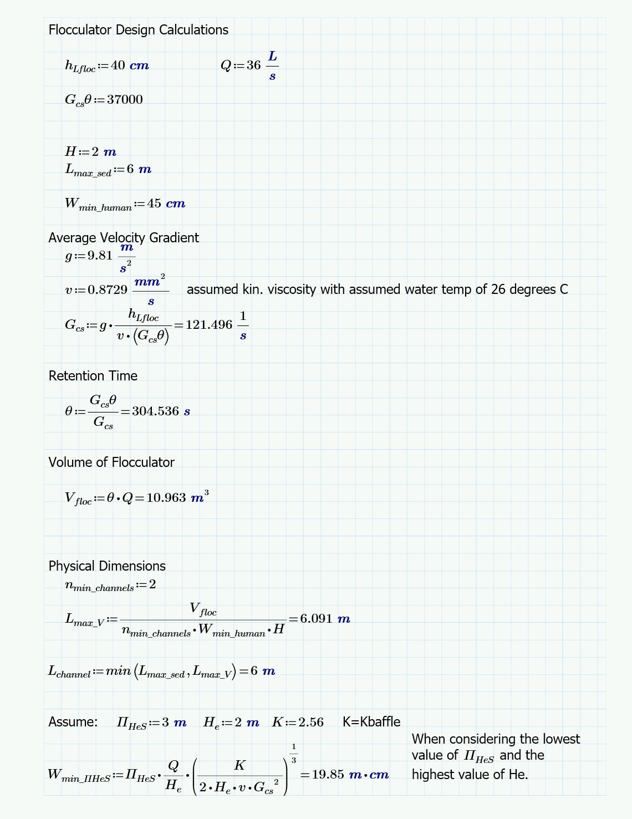

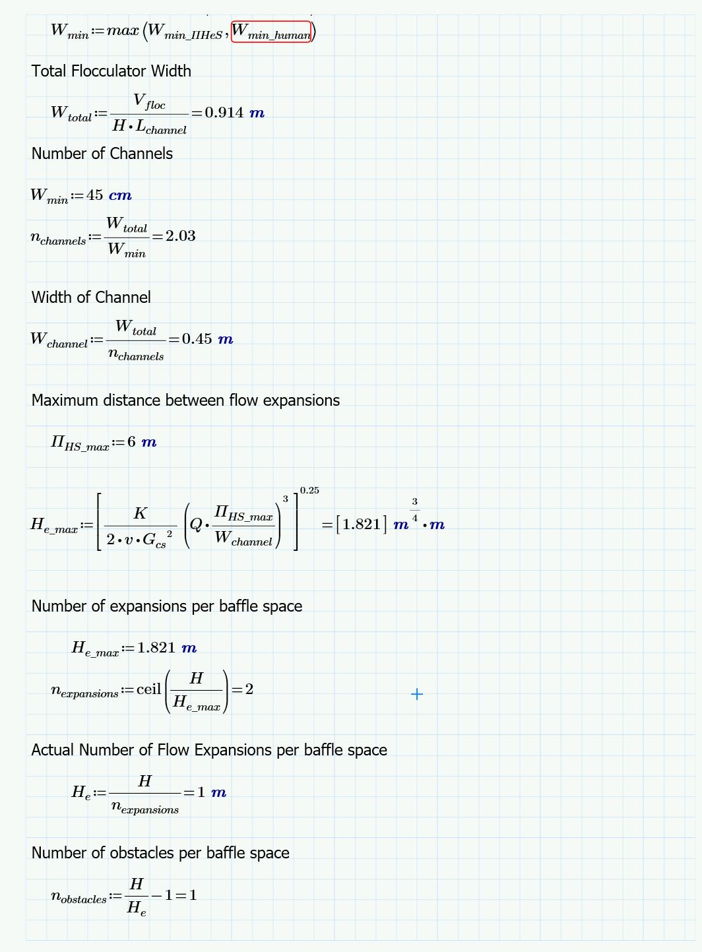

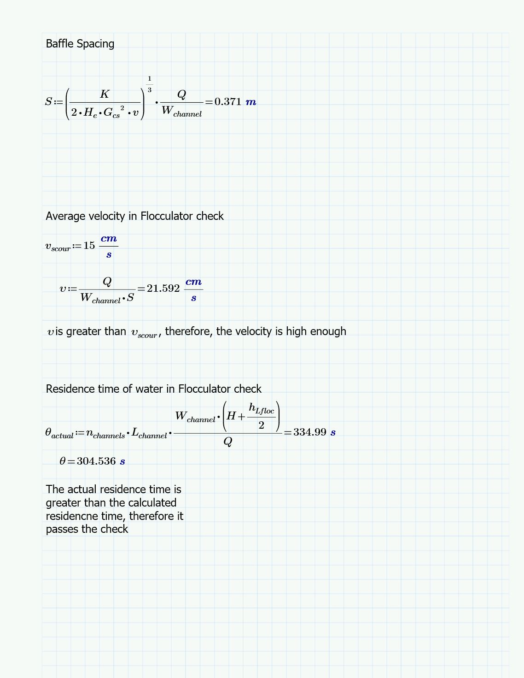

***Table 1:*** *Water quality data collected by Zaina Hussein (Ardhi University)*

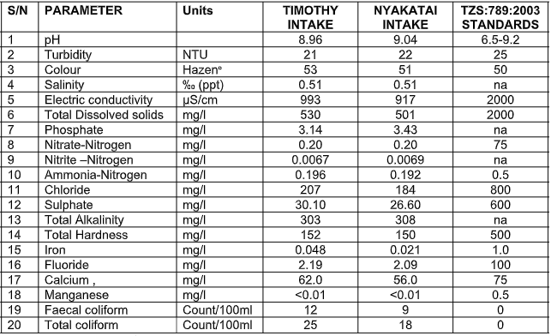

**Appendix B: Materials**

**CDC and LFOM:**

***Table 2:*** *Materials list with description of items for CDC and LFOM.*

|  |  |
| --- | --- |
| Item | Description |
| **Barbed Fittings** |  |
| Barbed fitting for CHT | Durable nylon single-barbed tube fitting connecting dosing tube to CHT |
| Barbed fittings for drop tubes | Allows for chemical/coagulant to enter drop tube from inner diameter connector tube |
| Reducing barbed fittings | Connects inner diameter dosing tube to inner diameter connector tube |
| **PVC** |  |
| Drop tubes | Clear plastic such that flow is observable. Lightweight, but must ensure free fall of chemical solution |
| Counterweight | Small section of PVC to be used as optional counterweight to float |
| Tee | Used for T-shaped slider assembly for higher flow plants |
| Pipe cap | Schedule 40 white PVC pipe attached to bottom of drop tubes and end of PVC-T |
| Square head plug | Threaded square head plug for top of float. Water tight but removable to allow weight to be added to float |
| Cap | Unthreaded cap for bottom of float |
| Pipe | Connects the adapter to PVC cap. Do not use more than necessary |
| **Tubing** |  |
| Large diameter (connector) | Clear plastic tubing to be used as a connector to the drop tube |
| Small diameter (dosing) | Clear plastic tubing attached to the base of the CHT and the connector tube by a reducing barbed fitting |
| **Constant Head Tank** |  |
| Plastic jar | Translucent plastic jar with hole drilled in the bottom center for the through-wall barbed fitting. Cover to prevent contamination of the chemical by particles in the ari. Small drilled hole to allow air flow. |
| **Float and Lever System** |  |
| Lever arm | Aluminum |
| Slider | Corrosion resistant aluminum, u-channel. Attached to the top of the lever arm to vary coagulant dose |
| Shaft collar | Aluminum; secured to either side of the lever arm to prevent the lever arm from displacing laterally along the shaft |
| Hex nut | For use between the drop tube and the slider, permits the drop tube to swing freely |
| Screws | One for the slider locking mechanism, one to hang the drop tube |
| Kerick float valve*** | Attached to side of the constant head tank to keep water level constant within CHT (***typically not available locally***) |
| Turnbuckle | Connects the float chain to lever-arm apparatus |
| **Miscellaneous** |  |
| Threaded adapter | Threaded adapter to receive the square head plug and convert to unthreaded pipe |
|  |  |
| **Linear Flow Orifice Meter** |  |
| PVC Pipe | Pipe for Linear Flow Orifice Meter. Drilled by uniform bit and in accordance with LFOM design algorithm to maintain linearity throughout the plant |

**Flocculation:  
*Table 3:*** *Approximate quantities required for the flocculation system.*

|  |  |  |  |  |
| --- | --- | --- | --- | --- |
| Material | Diameter/size | Amount | Length | Units |
| Top Baffle | 1.82 m high | 25 | N/A | N/A |
| Bottom Baffle | 1.28 m high | 24 | N/A | N/A |
| pvc pipe | 6 in | N/A | 1.7672 | meters |
| Floc Spacers | 0.75 in | N/A | 46.56 | meters |

**Sedimentation:  
*Table 4:*** *Approximate lengths of PVC pipe required for the entire sedimentation system.*

|  |  |  |
| --- | --- | --- |
| Diameter  mm (in) | Amount of Pipe m (ft) | SDR |
| 12.7 (0.5) | 198 (650) | 13.5 |
| 19.0 (0.75) | 198 (650) | 17 |
| 25.4 (1) | 10.5 (35) | 26 |
| Diffuser: 25.4 (1) | 83.7 (275) | 26 |
| 3.81 (1.5) | 105 (345) | 26 |
| 76.2 (3) | 43.5 (143) | 26 |
| 160 (6) | 38.84 (128) | 41 |
| 208 (8) | 38.74 (127) | 41 |

***Table 5:*** *Accessories required for the entire sedimentation system.*

|  |  |  |
| --- | --- | --- |
| Accessory | Diameter of Corresponding Pipe | Quantity |
| Outlet manifold fitting | 6 in | 6 |
| Outlet manifold end cap | 6 in | 6 |
| Outlet manifold plug | 6 in | 6 |
| Inlet Manifold 90 elbow | 8 in | 6 |
| Inlet Manifold fitting | 8 in | 6 |
| Inlet Manifold end cap | 8 in | 6 |
| Overflow T joint | 6 in | 1 |
| Overflow 90 elbow | 6 in | 1 |
| Overflow plug fitting | 6 in | 2 |
| Plate Support T Joints | 1.5 in | 22 |
| Plate Support 90 elbow | 1.5 in | 4 |
| Jet Reverser valve | 3 in | 6 |
| Floc Hopper drain valve | 1 in | 6 |
| Plate settlers | N/A | 1056 |

**Stacked Rapid Sand Filter:**

***Table 6:*** *Preliminary quantities required for the filtration system.*

|  |  |  |  |  |  |
| --- | --- | --- | --- | --- | --- |
| Item | Nominal Diameter | Amount | Length | Width | Height |
| PVC |  |  |  |  |  |
| Backwash pipe | 8 in |  |  |  |  |
| Filter Pipe | 6in |  |  |  |  |
| Sand outlet pipe | 2 in |  |  |  |  |
| siphon pipe | 8 in |  |  |  |  |
| exit waste pipe | 4 in |  |  |  |  |
| entrance overflow pipe | 6 in |  |  |  |  |
| inlet channel drain | 2 in |  |  |  |  |
| manifold branch | 1 in |  |  |  |  |
| backwash manifold branch | 1.50 in |  |  |  |  |
| filter branch holder | 2 in |  |  |  |  |
| filter bypass | 8 in |  |  |  |  |
| siphon manifold orifice | 2 in | 18 |  |  |  |
| manifold branch |  | 28 | 56 cm |  |  |
| backwash manifold branch |  |  | 53.5 |  |  |
| manifold orifice bw |  | 140(5 per branch) |  | 5 per branch |  |
| Material: Plastic Sheet (weir) |  |  |  |  |  |
| Stop Gate |  |  | 72.1 cm width |  | 20 cm |
| slot stopper |  | 3 |  |  | 70.8 cm |
| Material: Valves |  |  |  |  |  |
| siphon air valve | 0.750 in |  |  |  |  |
| backwash flush valve | 2 in |  |  |  |  |
| flush valve | 1.5 in |  |  |  |  |

**Appendix C: References**

**Weber-Shirk, Monrow, et al. *AguaClara Textbook*. Cornell University, 2019.**

**Encyclopaedia Britannica. Revised by: Hosch, William L. Eddy: Fluid Mechanics. https://www.britannica.com/science/eddy-fluid-mechanics**

**Appendix D: Drawings**